1. **Program To Convert Celsius To Fahrenheit :-**

C = int(input("Enter Your Temperature In Celsius"))

F=(C*9/5)+32

print("The Temeperature In Fahrenhiet is",F)

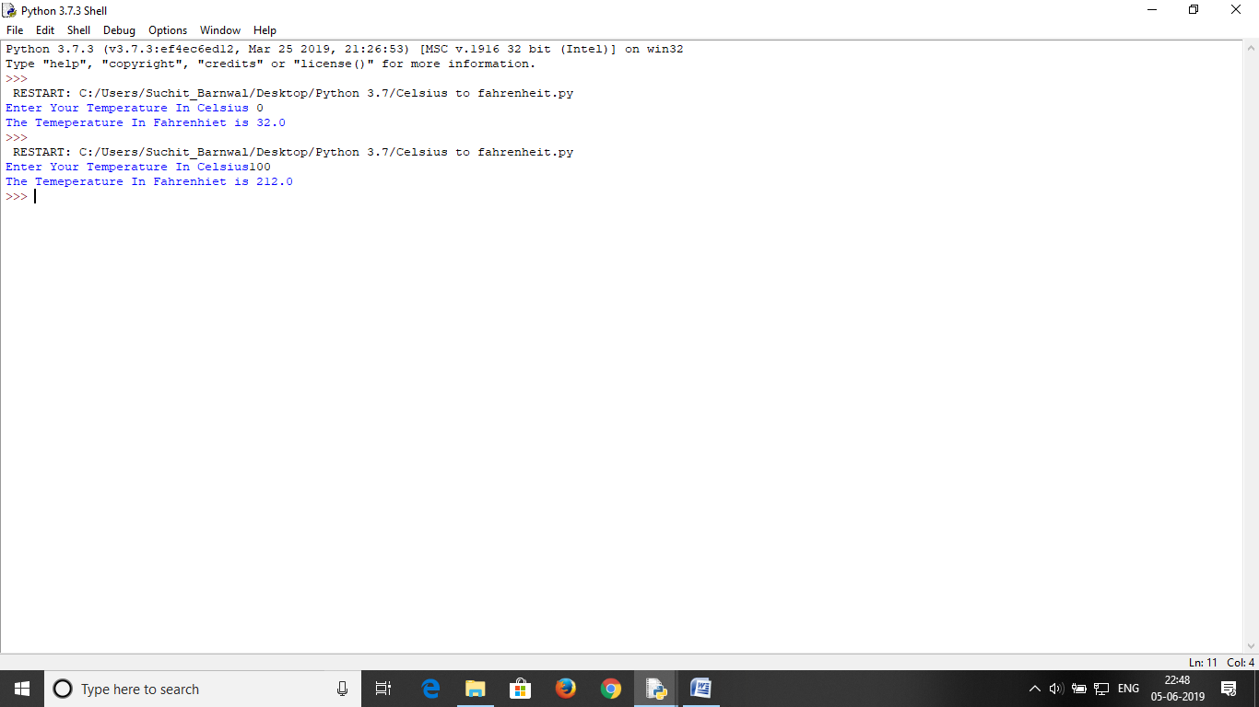

**(2) Program To Convert Fahrenheit To Celsius :-**

F= int(input("Enter Your Temperature In Fahrenheit"))

C= (F-32)*5/9

print("Your Temperature In Celsius is",C)

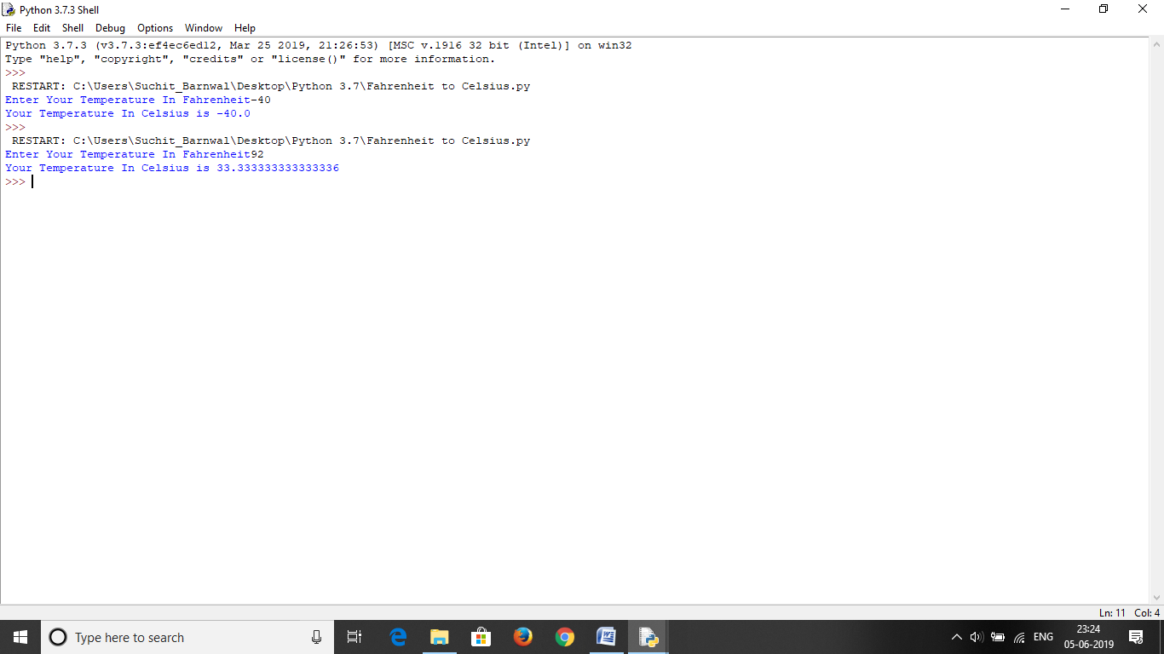

**(3) Program To Find Area And Perimeter Of Rectangle :-**

L= int(input(" Enter The Length Of Rectangle"))

B= int(input(" Enter The Breadth Of Rectangle"))

P= 2*(L+B)

A= L*B

print("The Perimeter Of Rectangle Is",P)

print("The Area Of Rectangle Is",A)

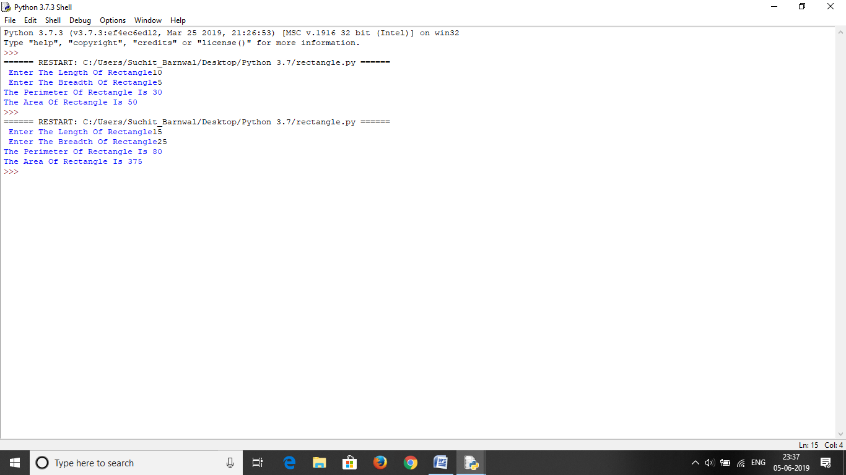

**(4) Program To Find Area And Perimeter Of Square :-**

S= int(input("Enter The Side Of Square"))

P= 4*S

A= S*S

print("The Perimeter Of Square is",P)

print("The Area Of Square is",A)

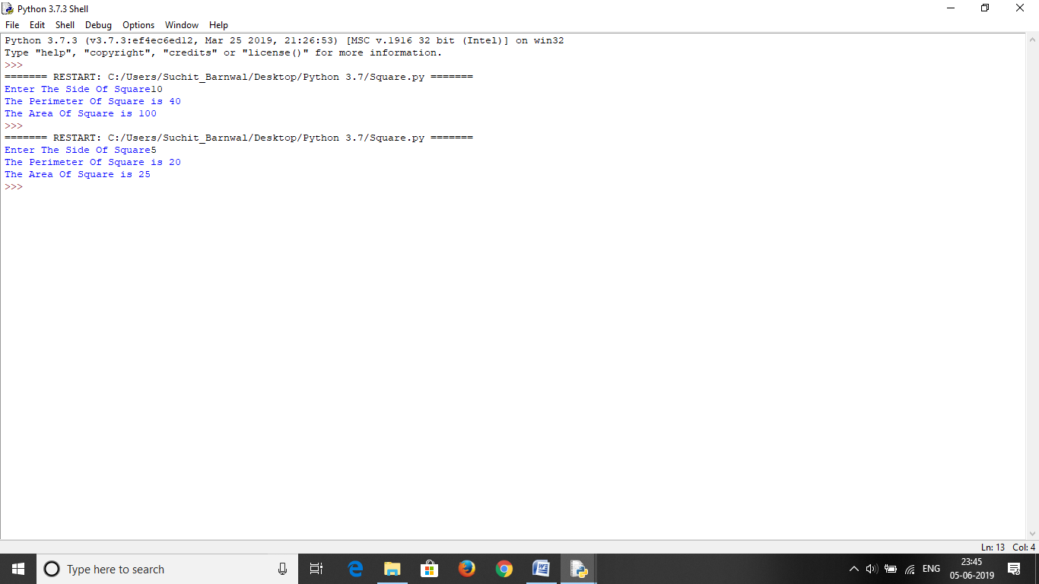

**(5) Program To Find Simple Interest And Compound Interest :-**

P=int(input("Enter The Princpal"))

R=int(input("Enter The rate Of Interest"))

T=int(input("Enter The Time"))

SI= (P*R*T)/100

CI= P*(1+(R/100))**T

print("The Simple Interest Is",SI)

print("The Compound Interest Is",CI)

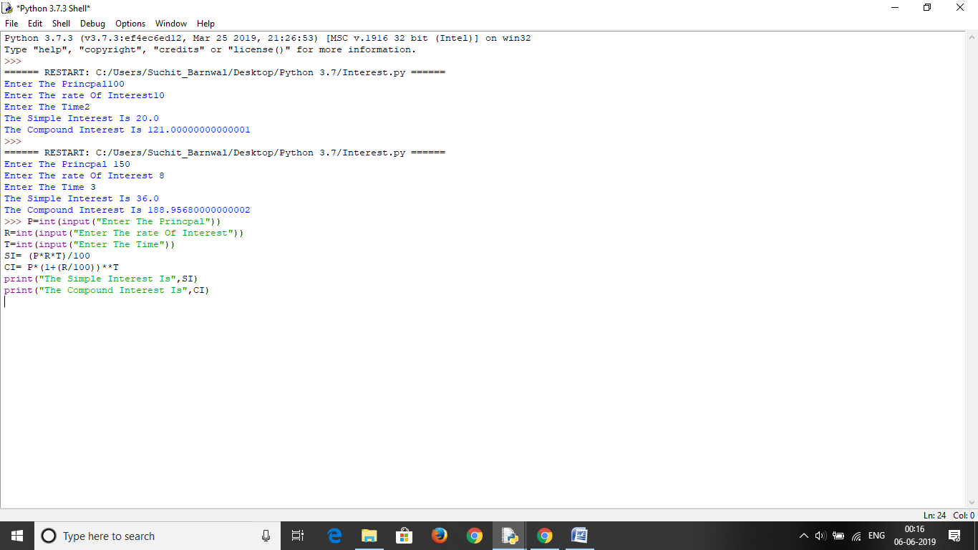

**(6) Program To Create Report Card:-**

n = input("Enter Your Name: ")

a = int(input("Enter Marks for English: "))

b = int(input("Enter Marks for Maths: "))

c = int(input("Enter Marks for Science: "))

d = int(input("Enter Marks for SST: "))

e = int(input("Enter Marks for Hindi: "))

s = a+b+c+d+e

p = (s/5)

print("Hi", n,"you got a total of", s,"/500 marks in your exams.")

print("Your average was ", p, "and total percentage was ", p*100/100,"%") 